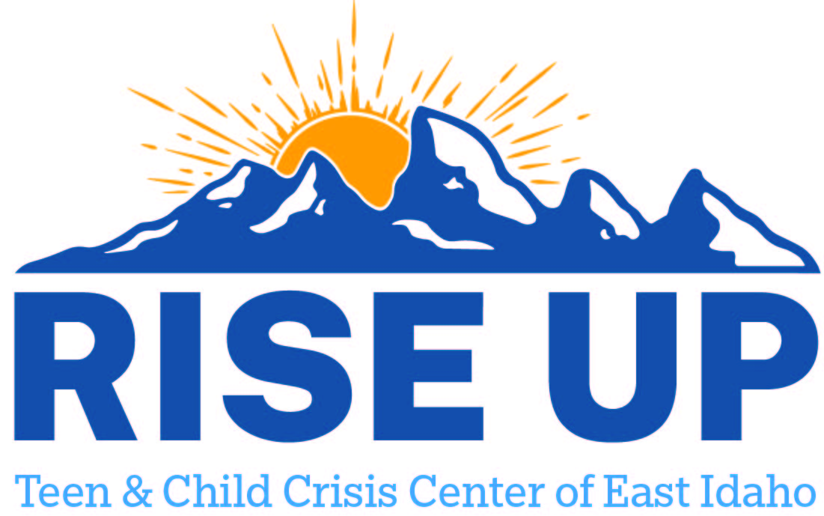

Resources for youth and teens to utilize as a support to individuals and family.
Teton County

Reddoor Rehabilitation INC
1420 N Highway 33 Ste 203
Driggs ID 83422
(208) 354-3005

TBT LLC
89 N Main St
Driggs ID 83422
(307) 734-6040

