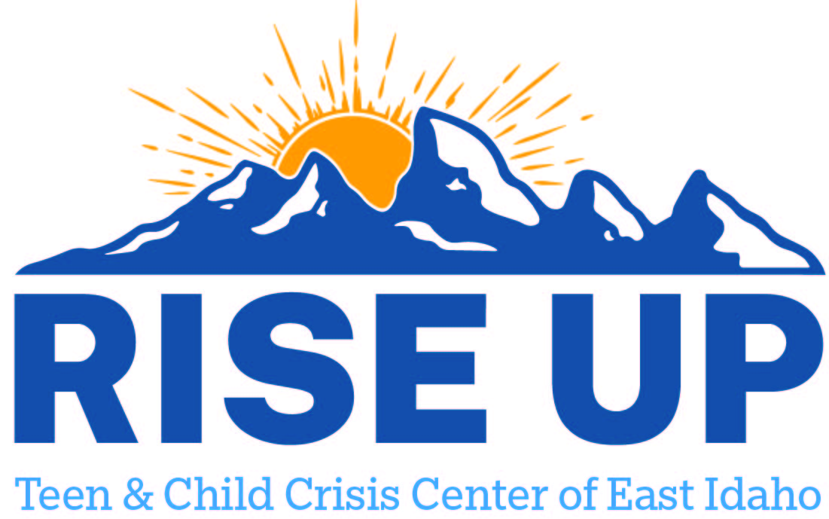

Resources for youth and teens to utilize as a support to individuals and family.
Madison County

AmericaHealth
(208) 356-4459
30 Madison Professional Park
Rexburg ID 83440

Centerpoint Counseling Services
(208) 359-4840
393 E 2nd N
Rexburg ID 83440

D7 Treatment
(208) 529-1854
859 S Yellowstone Hwy Ste 1101
Rexburg ID 83440

Child and Family Resources
(208) 356-4911
316 N 3rd E
Rexburg ID 83440

Integrity Mental Health
(208) 615-8159
160 Valley River Dr Ste 4
Rexburg ID 83440

Mountain View Hospital LLC
(208) 359-1700
404 N 2nd E
Rexburg ID 83440

Reddoor Rehabilitation INC
(208) 354-3005
1420 N Highway 33 Ste 203
Driggs ID 83422

R&R Counseling Rexburg Location
2590 S 2000 W Suite 2 Rexburg, ID 83440
1.208.356.0088
info@rrclinicalservices.com
Healing Spring Counseling
534 Trejo Street, Suite 200H Rexburg, ID 83440-5408
(208) 221-0468
FACS DDA Providers
Developmental Workshop Inc. | (208)524-1550 | Rexburg | Shirrie.Brown@dwinc.org
Royal Journeys LLC | (208)220-6986 | Rexburg | darci.kearn@journeysdda.com
Upper Valley Options Inc | (208)359-3133 | Rexburg | acevedoi2017@gmail.com

