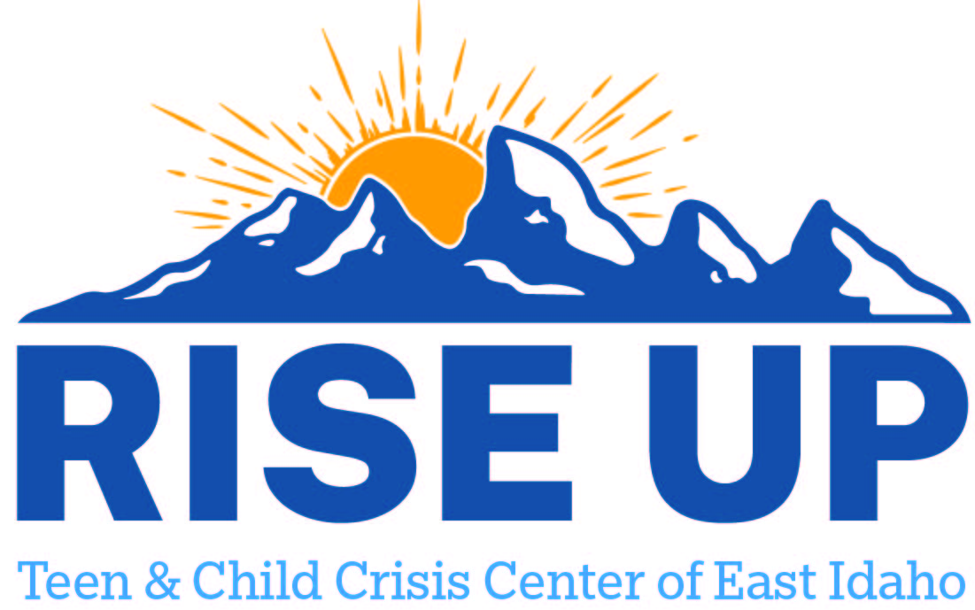

Resources for youth and teens to utilize as a support to individuals and family.
Lemhi County

Lemhi Valley Social Services Inc
1301 Main St Ste 7
Salmon ID 83467
(208) 756-2927
shannonn@lvssi.org
1301 Main St Ste 3B
Salmon ID 83467
anniemayaz@yahoo.com

Human Dynamics and Diagnostics LLC
111 Lillian St Ste 204
Salmon ID 83467
(208) 756-2344

Canvi Behavioral Health PLLC
600 Shanafelt St
Salmon ID 83467
(208) 252-5621

FACS DDA Providers
Human Dynamics and Diagnostics LLC | (208)522-0140  (Also see above) | Salmon | tashar@humandynamicsid.com

