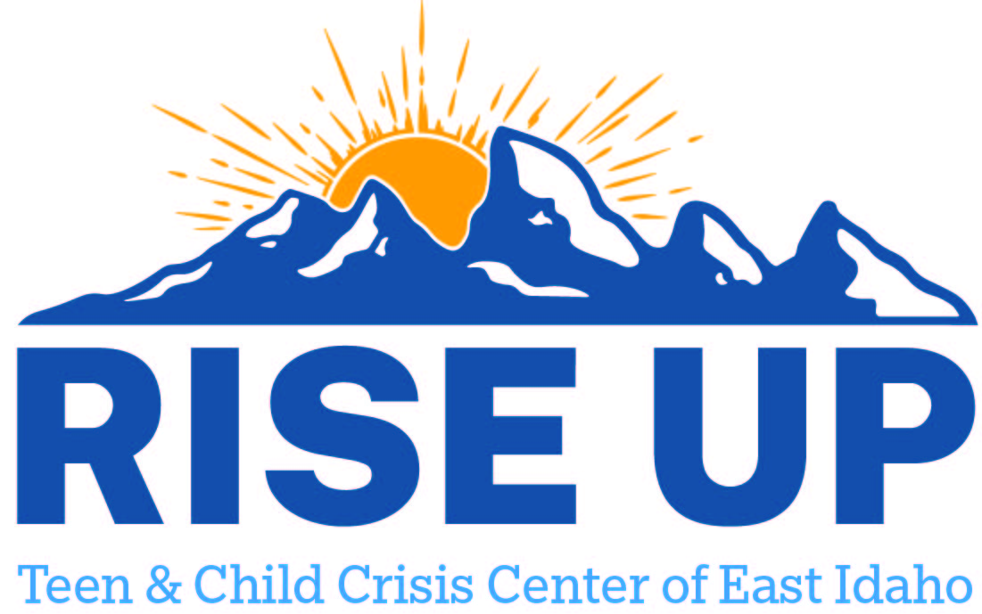

Resources for youth and teens to utilize as a support to individuals and family.
Jefferson County

Open Trails Counseling and Consulting PLLC
4129 E 200 N
Rigby ID 83442
(208) 557-1936

Mountain View Hospital LLC
167 E 1st S
Rigby ID 83442
(208) 745-8747

FACS DDA Providers
Royal Journeys LLC | (208)220-6986 | Rigby | darci.kearn@journeysdda.com

