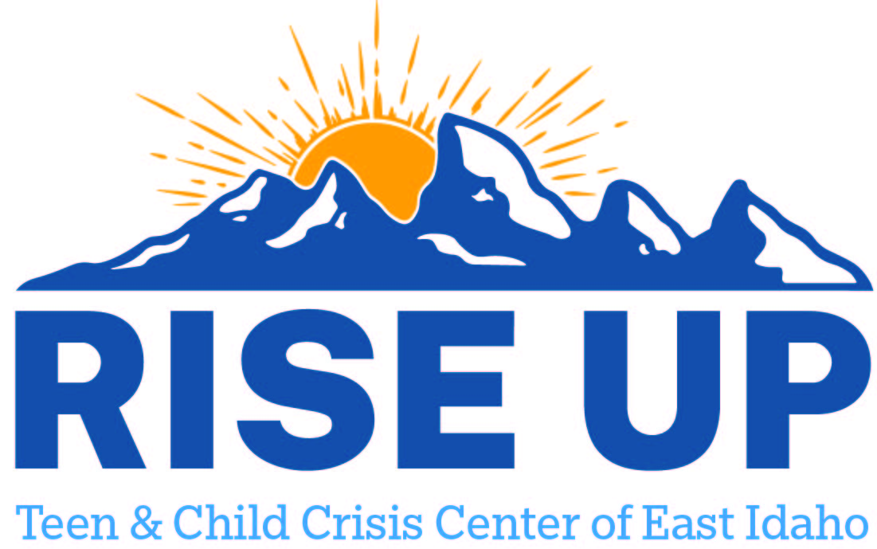

Resources for youth and teens to utilize as a support to individuals and family.
Fremont County

Upper Valley Community Health Services
335 E Main St
Saint Anthony ID 83445
(208) 356-4900
behavioralhealth@grandpeaks.org
Counseling

FACS DDA Providers
Excellence in Everyone LLC | (208)624-2002 | St. Anthony | excellencedda@yahoo.com

