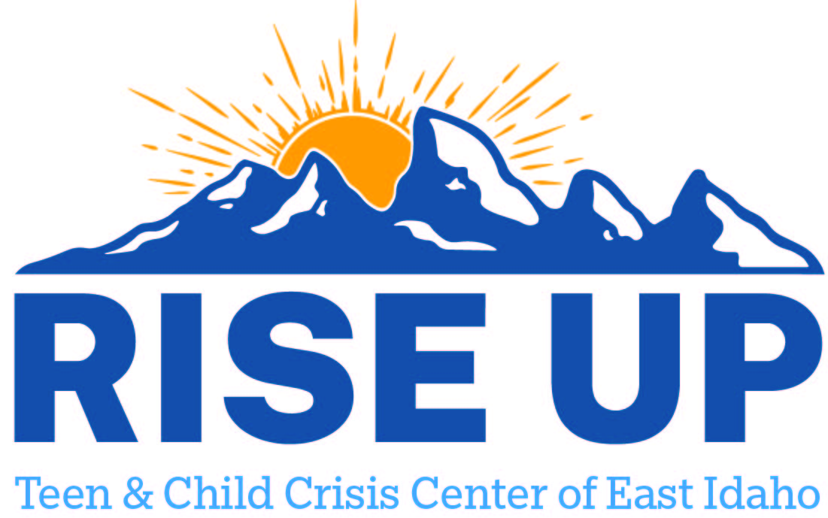

Resources for youth and teens to utilize as a support to individuals and family.
Custer County

Challis Area Health Center Incorporated
611 Clinic Rd
Challis ID 83226
(208) 879-4351
srembelski@cahcinc.com

