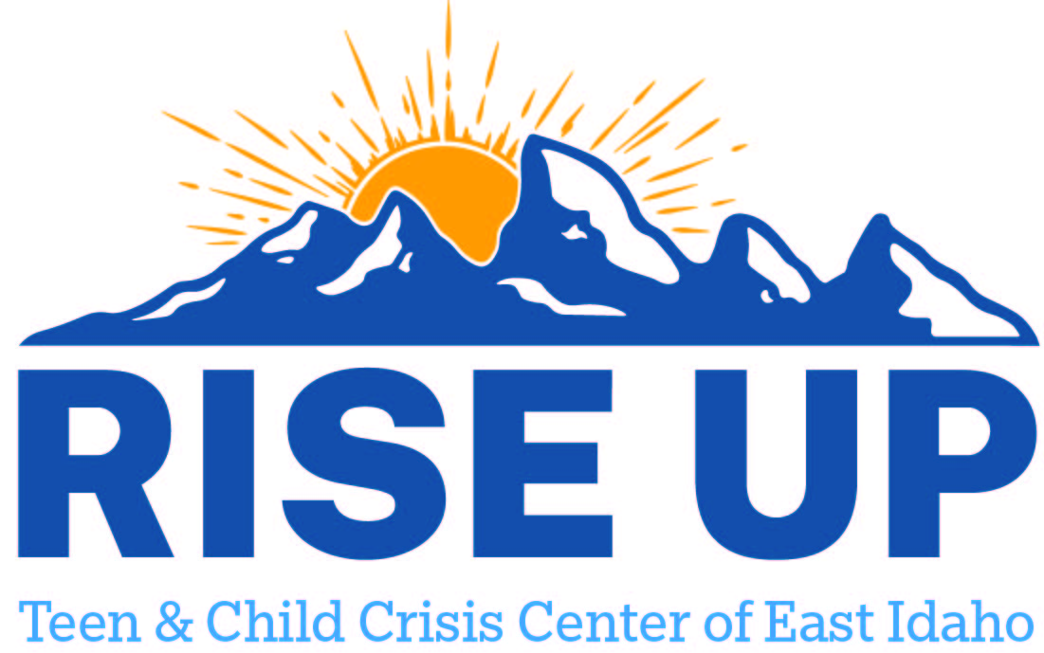

Resources for youth and teens to utilize as a support to individuals and family.
Idaho Falls

Mental Health Providers
All Star Counseling:  Therapy, CM, CBRS & Med Management  550 2nd St, Idaho Falls, ID 83401  (208) 529-2211  M-Thurs: 9-5 pm  What insurance?? | Nurturing Connections:  1379 E 17th St  Idaho Falls ID 83401  (208) 557-3336  M-F 9-5 pm (closed for lunch)
One Love Agency:  2235 E 25th St #190, Idaho Falls, ID 83404  (208) 991-4296  M-F: 9-5 pm  CBRS, CM | Teton Counseling:  Counseling  615 Hoopes Avenue Idaho Falls, ID 83401  208- 542-0352  M-F 8-6 pm
Answers:  Therapy, CM, CBRS & Med Management  855 N Capital Ave #1, Idaho Falls, ID 83402  (208) 552-0855  M-F: 9-6:30 pm | The Counseling Agency (formally wells spring) Private insurance – Hx for trauma & abuse
Tueller:  Therapy, CM, CBRS & Med Management  2275 W Broadway St # G, Idaho Falls, ID 83402  (208) 524-7400  M-F: 8- 6 pm | Wright Step counseling and recovery:  1904 Jennie Lee Dr, Idaho Falls, ID 83404  (208) 520-7074  M-F: 9-6 pm
Creekside Counseling:  550 W Sunnyside Rd, Idaho Falls, ID 83402  (208) 529-5777  M-F: 8-5:30 pm  Private insurance- First responder specialized | Childrens Supportive Services  1565 E Lincoln Rd  Idaho Falls ID 83401  (208) 524-8996  Therapy, CM, CBRS & Med Management  Respite  shawnatcss@gmail.com
Innovative Health Care:  115 E 16th St, Idaho Falls, ID 83404  (208) 523-1130 | Children and Family Clinic:  1327 East 17th Street, Idaho Falls ID 83404  208-538-3122  M-F: 9-5 pm (weekends only by appointment)
Pearl Health Clinic:  502 S Woodruff Ave, Idaho Falls ID 83401  Also 17th address  208-346-7500  M-F: 8-5 pm | Ascend:  2001 S Woodruff Ave Suite 9, Idaho Falls, ID 83404  (208) 419-3002  M-F: 8-5 pm
High Tide Psychiatry:  1500 Pancheri Drive, Suite 4 Idaho Falls, Idaho 83402  208- 579- 6087 (call or text)  M-Thurs: 9-5, Fri: 9-1 pm | Ideal Options (13 or older)  380 N Capital Ave Ste. #1, Idaho Falls, ID 83402  (877) 522-1275  M-Thurs: 7:30 – 6 pm
Beehive  490 Park Ave Ste 4  Idaho Falls ID 83402  (208) 612-5035 | VISTA  452 D St  Idaho Falls ID 83402  (208) 552-0355
Joshua D Smith & Associates  540 3rd St  Idaho Falls ID 83401  (208) 524-5607 | Padron  522 Lomax St  Idaho Falls ID 83401  (208) 522-6925
Stewards of Recovery  685 1st St, Idaho Falls, ID 83401  (208) 932-4493  recovery@sor4life.com  Housing email: housing@sor4life.com  M-TH 9:00am-6:00pm F 9:00am-5:00pm  Addiction (Youth Program, Youth Support and Life Skills) Case Management | Insight & Empowerment  1908 Jennie Lee Dr  Idaho Falls ID 83404  (208) 932-7048  insightandempowerment@outlook.com  Hours: M-TH 9:00am-6:00pm  F 9:00am-5:00pm (Weekends on request (9:00am-1:00pm)) Telehealth upon request  CM Service, Youth and Peer Services  Medicaid and most insurances
America Health  1301 E 17th St  Idaho Falls ID 83404  (208) 538-3122  Therapy, CM, CBRS & Med Management  Respite , Youth PHP | Community mental Health services  1400 Benton St  Idaho Falls ID 83401  (208) 525-8339  parrism@cmtyhealthid.com
Rediscovering wellness  1337 E 17th St, Idaho Falls, ID 83404  (208) 529-3786 | Counseling clinic of youth & family renewal  1600 John Adams Pkwy Ste 102  Idaho Falls ID 83401  (208) 523-0787
Woodhouse counseling  180 N Woodruff Ave  Idaho Falls ID 83401  (208) 346-0688 | Genshai Trauma  1820 E 17th St suite 190, Idaho Falls, ID 83404  (208) 406-6194
R & R Counseling  1970 East 17th Street Suite 204 Idaho Falls, ID 83404  1.208.356.0088  info@rrclinicalservices.com | Evergreen Counseling  1820 E. 17th Street Ste 240, Idaho Falls, ID, 83404, United States  (208) 710-9824  evergreencounselingif@gmail.com  M-F 9:00am-6:00pm
Bingham health care comprehensive clinic | Human Dynamics  2267 Teton Plz  Idaho Falls ID 83404  (208) 522-0140  Developmental Services
RHS: ESMI  1675 Curlew Dr, Ammon, ID 83406  (208) 523-5319  M-F: 8-6 pm | Pettingill counseling  1302 E 17th St, Idaho Falls, ID 83404  (208) 542-9919
Olive Branch Counseling  2539 Channing Way suite 102, Idaho Falls, ID 83404  (208) 419-0800  Private pay only | Ritchie & Taylor Counseling  2539 Channing Way, Idaho Falls, ID 83404  (208) 932-0228
Open Trails Counseling & Consulting  2539 Channing Way Ste 101  Idaho Falls ID 83404  (208) 521-9946 | High Country Behavioral Health  1248 E 17th St, Idaho Falls, ID 83404  (208) 542-1026  CBRS, CM, Peer Support, Drug and Alcohol,
Lean on Me  1425 Cambridge Dr  Idaho Falls ID 83401  (208) 932-1743  andreshouse@lomainc.org | Reddoor Rehabilitation  211 S Woodruff Ave  Idaho Falls ID 83401  (208) 354-3005  CM, CBRS, Peer, Med Management, Respite  info@reddoorsupports.com
Willow Sage  211 S Woodruff Ave Ste A3  Idaho Falls ID 83401  (208) 524-4818  willowsageservices@gmail.com | Mountain West Supportive Services  1970 E 17th St Ste 208  Idaho Falls ID 83404  (208) 715-0218
Snake River Counseling Center  1970 E 17th St Ste 121  Idaho Falls ID 83404  (208) 552-0490  julipims@gmail.com | Eastern Idaho Health Services  2860 Channing Way Ste 225  Idaho Falls ID 83404  (208) 227-2555  shawn.lapray@hcahealthcare.com
Healthy Care Solutions  3522 Briar Creek Ln  Ammon ID 83406  (208) 529-1660  nandersen@healthycaresolutionsllc.com | Access Point  2222 Teton Plaza Suite 2  Idaho Falls ID 83404  (208) 522-4026  Developmental Services
Healing Spring Couseling
534 Trejo Street, Suite 200H
Rexburg, ID 83440-5408
(208) 221-0468

**East Idaho Youth Homes (Respite & residential treatment options)
550 Linden Dr, Idaho Falls, ID 83401
(208) 821-6360
24 hour facility

Gustafson House (72 hour respite program):
2935 Rollandet Avenue, Idaho Falls, ID 83402
(208) 542-2905

Homeless options once turn 18
Ruth’s House (Women’s Shelter):
3130 S Yellowstone Hwy, Idaho Falls, ID 83402
(208) 419-0808
Supervisor: Jennifer Murray

Haven Women and Children:
2480 S Yellowstone Hwy, Idaho Falls, ID 83402
(208) 523-6413
Supervisor: Maggie Postiglione

City of Refuge (Mens Shelter)
840 Park Ave, Idaho Falls, ID 83402
(208) 552-5575
Supervisor: Sean Vedro

Community Resources:
Community Youth in Action (C-YA), LIV Center
574 4th Street, Idaho falls ID 83401
208-926-6633

SPARC
574 4th Street, Idaho falls ID 83401
208-544-4357

CYA: Focus on community volunteer projects, substance abuse and suicide prevention, youth leadership, evidence-based prevention classes, safe & sober activities, parent education, the annual TRAPPED Leadership Retreat, school assemblies, community presentations, and parent education.
LIV: Teen center that provides daily transportation, meals, after-school tutoring, and enrichment classes for all area youth grades 7-12. “Classes include STEM, art, music, fitness, cooking, adulting 101, crafts, support groups, sewing, photography, and more.” **After School Hours available**
SPARC: This team assists youth and families to connect to resources available in the community, such as food, clothing, and medical & mental health needs. They are available to screen youth to determine the best resources available in our community to meet their needs. This team is available on call 24 hours (208) 544-4357 to provide a safe place for youth. They aim to prevent youth from entering the Juvenile Justice System, Behavior Health Hospital, or Health and Welfare System.

FACS DDA Providers
A New Hope LLC | (208) 904-1950 | Idaho Falls | d.white@anewhope.us
Access Point Family Services Inc. | (208)522-4026 | Idaho Falls | holly@accesspointkids.com
Ambitions of Idaho | (208)676-9395 | Idaho Falls | s.hagel@id.ambitions.org
Aspen Consulting and Management Services LLC | (208)534-8303 | Idaho Falls | aspenmh@outlook.com
Developmental Workshop Inc. | (208)524-1550 | Idaho Falls | Shirrie.Brown@dwinc.org
Human Dynamics and Diagnostics LLC | (208)522-0140 | Idaho Falls | tashar@humandynamicsid.com
Innovative Health Care Concepts Inc | (208)529-8526 | Idaho Falls | craigmorrison@ihccinc.com
Julius Behavioral Corp | (986)497-0701 | Idaho Falls | tawnya@juliusbehavioral.com
Riverside Service Group Inc | (208)542-4517 | Idaho Falls | shawn@rivserv.com
Royal Journeys LLC | (208)220-6986 | Idaho Falls | darci.kearn@journeysdda.com
The Adventure Center | (208)528-8639 | Idaho Falls | kathizamom@msn.com
Transitions Inc | (208)524-5771 | Idaho Falls | tyler.dahike@transitionsdda.com
Upper Valley Options Inc | (208)359-3133 | Idaho Falls | Acevedoi2017@gmail.com
 |  | Idaho Falls

