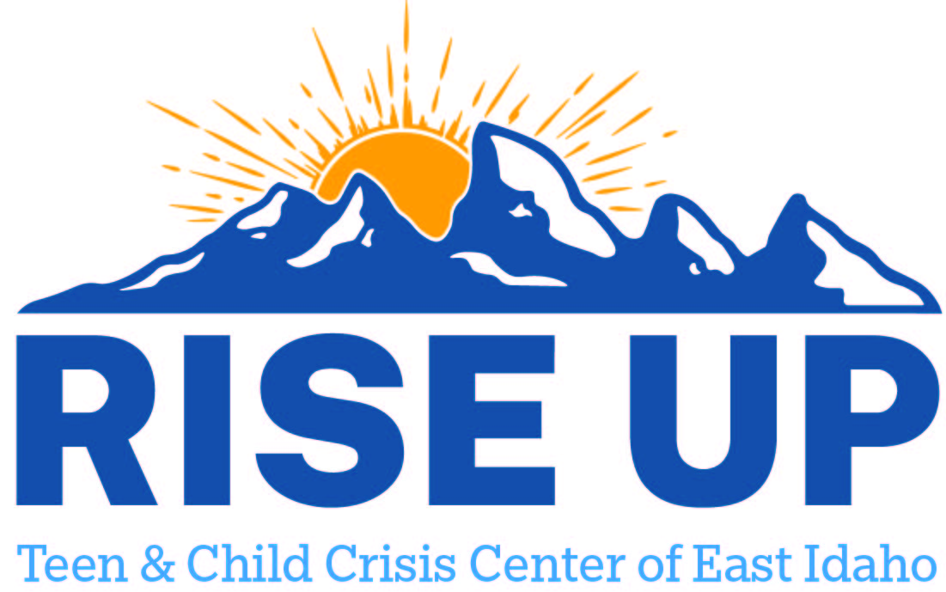

Resources for youth and teens to utilize as a support to individuals and family.
Bingham County

Mental Health Specialists
745 W Bridge St Ste F
Blackfoot ID 83221
(208) 238-9000

Community Family Clinic
625 W Pacific St Ste 3
Blackfoot ID 83221
(208) 528-7655

D7 Treatment
284 W Bridge St
Blackfoot ID 83221
(208) 529-1854

Awareness Center for Counseling
199 W Bridge St
Blackfoot ID 83221
(208) 782-2060

J & M Mental Health Inc
60 N Broadway St
Blackfoot ID 83221
(208) 782-3434

Stewards of Recovery
495 Emerald Ave
Blackfoot ID 83221
(208) 932-4493

Canvi Behavioral Health PLLC
898 S Meridian St
Blackfoot ID 83221
(208) 252-5621

Still Waters Counseling LLC
1309 Camas St
Blackfoot ID 83221
(208) 782-0675

Pacific Rim Consulting LLC
56 W Agency Rd
Fort Hall ID 83202
(208) 232-8840

Shoshone Bannock Clinic
717 Mission Rd
Fort Hall ID 83203
(208) 478-4026

