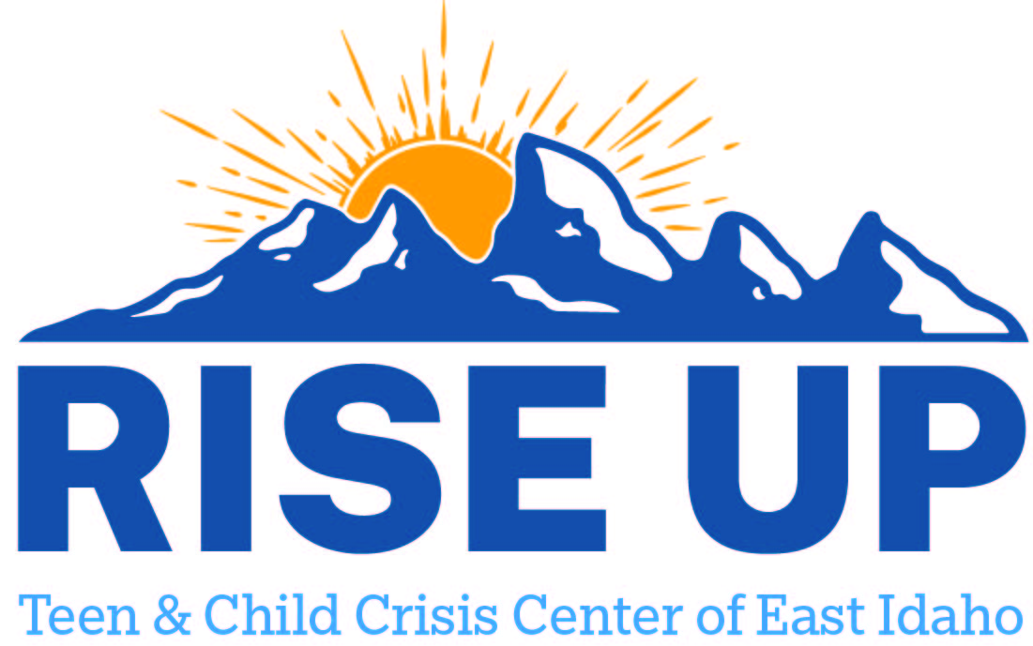

Resources for youth and teens to utilize as a support to individuals and family.
Power County

Health West Inc
823 Reed St
American Falls ID 83211
(208) 226-2822
330 N Main
Aberdeen ID 83210
(208) 397-4126
880 W Quinn Rd
Chubbuck ID 83202
(208) 238-2000
465 Memorial Dr
Pocatello ID 83201
(208) 234-4700

Falls Family Counseling
745 Reed St
American Falls ID 83211
(208) 266-2294

Center Counseling LLC
20 Hillcrest Ave
American Falls ID 83211
(208) 237-1711
265 E Chubbuck Rd
Chubbuck ID 83202
(208) 237-1711
centercounseling.office@gmail.com
centercounseling.office@gmail.com
Counseling, Med management, CM, CBRS, TCC, Peer/Youth Support, Family, Respite

Canvi Behavioral Health PLLC
645 W Clark St
Pocatello ID 83204
(208) 252-5621
333 W Cedar St Ste 3
Pocatello ID 83201
(208) 252-5621

Consumer Care LLC
645 W Clark St
Pocatello ID 83204
(208) 234-9361

A New Way Inc
809 N Arthur Ave
Pocatello ID 83204
(208) 233-4634

Hope Tree Inc
109 N Arthur Ave Ste 203
Pocatello ID 83204
(208) 234-4673

Candlewood Family Counseling Center Inc.
335 N Main St
Pocatello ID 83204
(208) 478-8340

AmericaHealth
165 N Main St
Pocatello ID 83204
(208) 524-7733
400 Yellowstone Ave
Pocatello ID 83201

Pacific Rim Consulting LLC
101 S Main St
Pocatello ID 83204
(208) 232-8840
lisa.robinson@byfhome.com

Moonlight Mountain Recovery Inc
151 N 3rd Ave
Pocatello ID 83201
(208) 505-9990

Gateway Counseling Inc
151 N 3rd Ave Ste 330
Pocatello ID 83201
(208) 242-3771
jaime.gateway@gmail.com

Adkins Counseling Services LLC
151 N 3rd Ave Ste 400
Pocatello ID 83201
(208) 840-1992
Josie@adkinscounseling.com
Counseling only

Cognitive Restructuring Llc
707 N 7th Ave Ste D
Pocatello ID 83201
(208) 242-3044
jody@cognitiverestructuring.org

Community Mental Health Services
720 E Lander St
Pocatello ID 83201
(208) 478-2172
parrism@cmtyhealthid.com

Allies Family Solutions
818 E Lander St
Pocatello ID 83201
(208) 234-2094
drcherilynnatkins@gmail.com

MVH PMHS LLC
475 Yellowstone Ave Ste E
Pocatello ID 83201
(208) 232-0021
hfumich@mvhospital.net

Bright Tomorrows
409 Washington Ave
Pocatello ID 83201
(208) 234-2646
sylvia@brightcac.org

Pearl Health Clinic
500 S 11th Ave Ste 203
Pocatello ID 83201
(208) 346-7500

Mental Health Specialists
210 W Burnside Ave Ste A
Chubbuck ID 83202
(208) 238-9000
CBRS, CM, Peer Support, Med Management, therapy, groups

High Country Behavioral Health
1777 E Clark St Ste 330
Pocatello ID 83201
(208) 478-9081
maryannw@hcbh.org

T Help LLC
4737 S Afton Pl Ste A
Chubbuck ID 83202
(208) 417-0623
sanctuary.ntc@gmail.com

Bannock Youth Foundation
110 S 19th Ave
Pocatello ID 83201
(208) 234-4722
cindyhansen@hotmail.com

