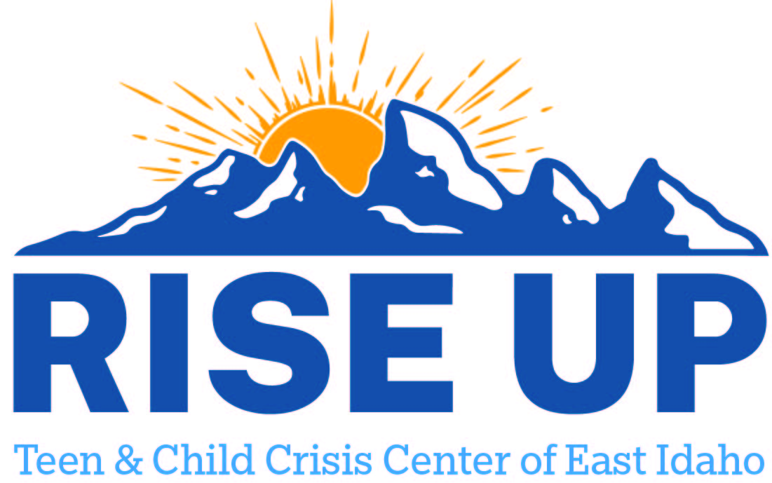

Resources for youth and teens to utilize as a support to individuals and family.
Franklin County

Priestley Mental Health Inc
75 S 1st W
Preston ID 83263
(208) 852-2370
pmh.admin@pmhinc.net

Health West Inc
655 S 4th E Ste 600
Preston ID 83263
(208) 852-3200

79 N Main St
Downey ID 83234
(208) 776-5202

Developmental Disabilities Administration (DDA)

Franklin County Developmental Services

Preston ID

(208)852-0324

rphillips@fcmc.org

