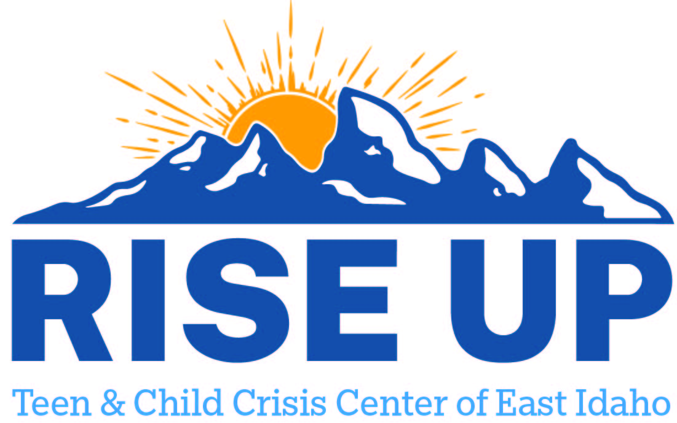

Resources for youth and teens to utilize as a support to individuals and family.
Caribou County

Portneuf Valley Family Center
15 W Center St Ste 2
Soda Springs ID 83276
(208) 547-4470

Caribou Medical Center Inc
300 S 3rd W
Soda Springs ID 83276
(208) 547-3341

Health West Inc
85 S 5th West
Lava Hot Springs ID 83246
(208) 776-5202

