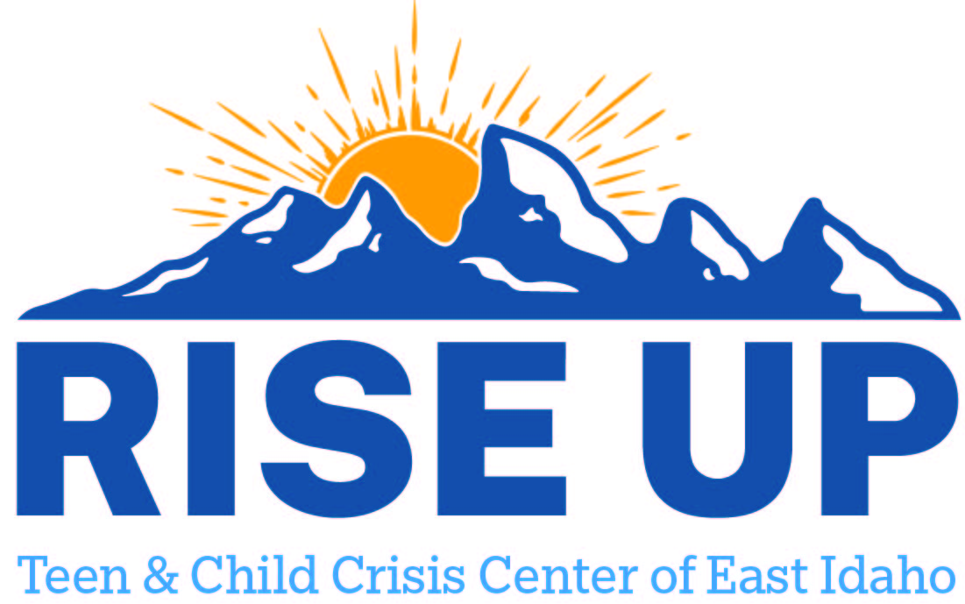

Resources for youth and teens to utilize as a support to individuals and family.
Bear Lake County

Bear Lake Memorial Hospital Mental Health
164 S 5th St
Montpelier ID 83254
(208) 847-4464

Bear Lake Community Health Center
152 S 4th St
Montpelier ID 83254
(435) 755-6061
credentialing@blchc.org

