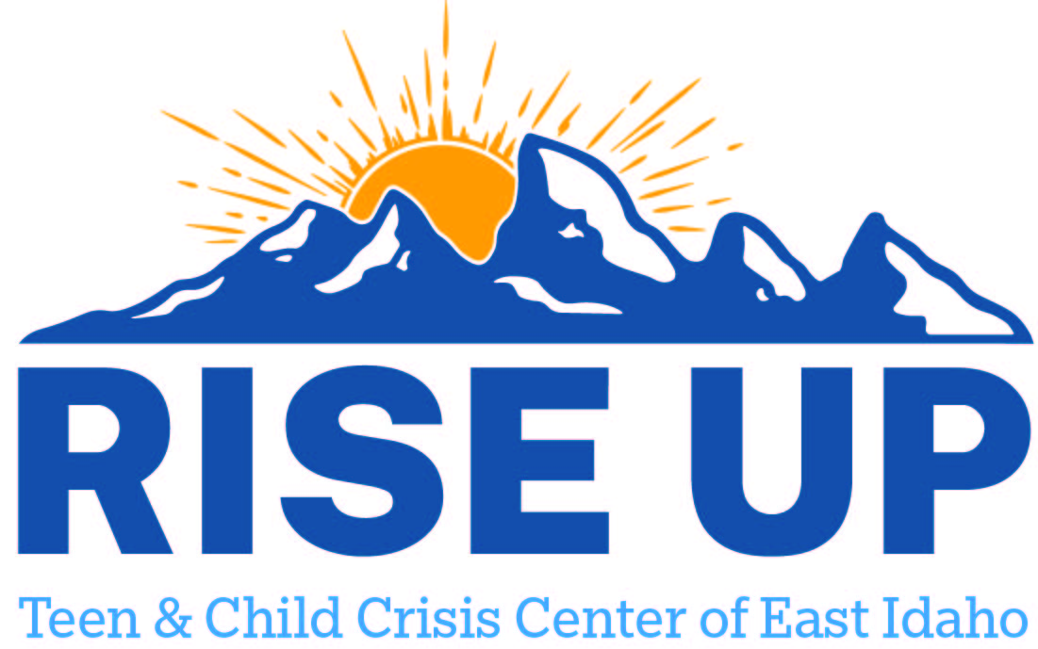

Resources for youth and teens to utilize as a support to individuals and family.
Bannock County

AmericaHealth
165 N Main St
Pocatello ID 83204
(208) 524-7733
Best, LLC (Behavioral Enhancement Services & treatment)
1001 N 7th Ave Ste 115
Pocatello, ID 83201
208-223-0240

Canvi Behavioral Health PLLC
1957 Alvin Ricken Dr
Pocatello ID 83201
(208) 252-5621
444 Hospital Way
Pocatello ID 83201
(208) 252-5621

Gateway Counseling Inc
151 N 3rd Ave Ste 330
Pocatello ID 83201
(208) 242-3771

Health West Inc
85 S 5th West
Lava Hot Springs ID 83246
(208) 776-5202
79 N Main St
Downey ID 83234
(208) 776-5202
500 S 11th Ave Ste 204
Pocatello ID 83201
(208) 232-6260

Hope Tree Inc
109 N Arthur Ave Ste 203
Pocatello ID 83204
(208) 234-4673

Joshua D. Smith and Associates
209 E Lewis St
Pocatello ID 83201
(208) 233-7693

Life Change Associates
2520 S 5th Ave
Pocatello ID 83204
(208) 233-5433

1957 Alvin Ricken Dr
Pocatello ID 83201
(208) 233-5433

Moonlight Mountain Recovery Inc
5230 W Moonlight Mine Rd
Pocatello ID 83201
(208) 505-9990
151 N 3rd Ave Ste 103
Pocatello ID 83201
(208) 505-9990

Pacific Rim Consulting LLC
101 S Main St
Pocatello ID 83204
(208) 232-8840

Pearl Health Clinic
500 S 11th Ave Ste 203
Pocatello ID 83201
(208) 346-7500

Pocatello Health Services LLC
500 S 11th Ave Ste 303
Pocatello ID 83201
(208) 239-3815

Portneuf Valley Family Center
444 Hospital Way Ste 477
Pocatello ID 83201
(208) 233-7832

Raise the Bottom Training and Counseling Services
2785 Bannock Hwy
Pocatello ID 83204
(208) 904-2654

Developmental Disabilities Administration (DDA)

A New Hope LLC
150 N Main St Ste 200
Pocatello, ID 83204
(208) 904-1950
d.white@anewhope.us

Access Point Family Services Inc.
Chubbuck ID.
(208) 522-4026
holly@accesspointkids.com

ALLIES Family Solutions
818 E Lander St
Pocatello ID 832201
(208) 234-2094
alliesdda@gmail.com

Prosper DDA
2293 Jacqueline Lane
Pocatello ID 83201
(208) 821-7410
prosperdda@gmail.com

Royal Joyrneys
Pocatello, ID
(208) 220-6986
darci.kearn@journeysdda.com

